**Nanotechnology Lesson Plan**

**At a Glance**

**Essential Question:** What is nanotechnology and how can it be used to improve the world around us?

**Essential Goal for the Unit:** To give 10th-12th grade students a basic understanding of nanotechnology by using manipulatives and hands-on projects. Refer to the attached Powerpoint for the lessons on each topic.

**What is Nanotechnology?** Nanoscience and nanotechnology are the study and application of extremely small things and can be used across all the other science fields, such as chemistry, biology, physics, materials science, and engineering.

**Standards**

**Engineering Design**

Students who demonstrate understanding can:

* Analyze a major global challenge to specify qualitative and quantitative criteria and constraints for solutions that account for societal needs and wants**.**
* Develop possible solutions**.** When evaluating solutions, it is important to take into account a range of constraints, including cost, safety, reliability, and aesthetics, and to consider social, cultural, and environmental impacts.
* Engage effectively in a range of collaborative discussions (one-on-one, in groups, and teacher led) with diverse partners on science and nanotechnology*,* building on others’ ideas and expressing their own clearly. Pose questions that connect the ideas of several speakers and respond to others’ questions and comments with relevant evidence, observations, and ideas.
* Apply principles of chemistry to nanotechnology, drawing comparisons between the two and understanding how they are connected.
* Discuss the impacts nanotechnology has on the environment.

**NGSS Standards:**

* HS-PS2-6. Communicate scientific and technical information about why the molecular-level structure is important in the functioning of designed materials.
* HS-ESS3-4. Evaluate or refine a technological solution that reduces impacts of human activities on natural systems.
* HS-ETS1-2. Design a solution to a complex real-world problem by breaking it down into smaller, more manageable problems that can be solved through engineering.

**Indiana Standards:**

C.3.6 Use structural formulas of hydrocarbons to illustrate carbon's ability to form single and multiple bonds within a molecule.

EDD-2.2 Create multiple potential solutions to a problem.

PS.7: Look for and make use of structure.

**Materials Required**

* LSME Nanotechnology Kit
* Wash bottle (not included)
* Paper towels (not included)
* Water (not included)
* Nanotechnology [PowerPoint Presentation](https://docs.google.com/presentation/d/1D56e0E4evrxVUKvw85EQdg6UlN6K_izAR1UHV9UO6vI/edit?usp=sharing)

**Safety Precautions**

* Small Parts, choking hazard.
* Students will be working with water, make sure that no unsafe behavior being practiced.

|  |  |  |  |
| --- | --- | --- | --- |
| **Lessons** | | | |
| **Lesson** | **Name of the Lesson** | **Corresponding Activity** | **Materials For Activity** |
| 1 | Hydrophobic and Hydrophilic Properties  Nanotechnology in Material Science | Nano-Fabric Experiment  “Magic” Sand Experiment | * 2 Bandanas * 2 Bags of sand * 2 Clear Plastic Cups * 2 Spoons * Water (not included) * Paper Towels (not included) * Wash or spray bottle (not included) * Station Instructions |
| 2 | Carbon-60 Buckyball | Build-a-BuckyBall | * Bonds and Carbon Atoms * Station Instructions |
| 3 | Carbon Nanotubes | Build-a-Nanotube | * Bonds and Carbon Atoms * Station Instructions |

**Major Concepts**

* Nanotechnology in material science
* Nanotechnology in structures such as buckyballs and nanotubes
* Nanotechnology and its effects on the environment

**Objectives**

Students will:

* Gain understanding about nanotechnology, its uses and its environmental applications as well as hydrophobic and hydrophilic properties through generation of original ideas and the construction of molecular models.
* Work in a team to record data and build molecular models
* Apply their knowledge of nanotechnology, its properties and its uses, to devise creative solutions to real-world problems.
* Describe the relationship between a molecule’s structure and its properties when interacting with water.

**Lesson Preparation**

**Preparation**

* Set up 10 working stations for students, and divide up the students accordingly.
* Since students will be working with water, paper towels should be present at each station.
* Each station gets one kit, one set of station instructions, and a student worksheet for each student within the group.
* Set up the powerpoint, so that it can be shown to students easily before any of the activities are conducted.

**Lessons**

**Lesson 1:** Background Information & Hydrophobic and Hydrophilic Properties

**Essential Question:** How can we visually represent hydrophobic and hydrophilic properties? How can they be applied to everyday objects? What are the benefits of using hydrophobic and hydrophilic products? What are the impacts of hydrophobic and hydrophilic products on the environment?

**Objectives:** Students should be able to identify the differences between hydrophobic and hydrophilic, both on a microscopic and macroscopic scale. Students should be able to summarize the Lotus Effect and its connection to nanotechnology, environmental science, and chemistry.

**Class Explanation:** The students will be introduced to the terms hydrophilic and hydrophobic through the included presentation. The students will be given pieces of fabric, but they will not be told if they have been treated with the hydrophobic spray or not. Working in groups or individually, they have to determine if the fabric is hydrophilic or hydrophobic using the substances given.

**Goal:** The purpose of this experiment is to prompt students to think about the possible uses for the hydrophobic properties of Nanotechnology in material science and construction.

**Materials Required:** 2 Bandanas, 2 Bags of sand, 2 Clear Plastic Cups, 2 Spoons , Water (not included) , Paper Towels (not included), Wash or spray bottle (not included), paper towels (not included), and Station Instructions.

**Given Information:**

* Present Power Point at the beginning of this lesson
* The word Hydrophilic comes from the Greek roots meaning “water” and “loving”.  
  Hydrophilic compounds tend to dissolve readily in water, or simply do not repel it.  
  Hydrophilic compounds are usually polar or ionic in nature. Some examples include sodium chloride (an ionic salt) and ethanol (a polar compound).
* The word Hydrophobic comes from the Greek roots meaning “water” and “fearing”.  
  Hydrophobic compounds do not dissolve in water, and some hydrophobic compounds will actively repel water.  
  Hydrophobic compounds are generally nonpolar in nature, and resemble lipids (i.e. oils and fats). Examples include fats (lipids) and decane (a nonpolar molecule).

**Procedure**

1. Students will be working in their assigned groups.

*Nano-Fabric*

1. Have the students pour water on the first bandanna. Have students raise the fabric into the air to see if the water is going through the fabric or whether it is bouncing off.
2. Have the students repeat with the other bandanna.
3. Encourage the students to document their observations in order to participate in a class discussion.
4. Discuss with the students what is happening. Is this fabric hydrophilic or hydrophobic?

*Nano-Sand*

1. Have the students pour the two different bags of sand into the two cups inside of their kit.
2. Ensure that students are documenting their predictions for which is hydrophobic or hydrophilic
3. Have the students fill their cups with water until their is approximately an equal amount of water as there is sand.
4. Have the students remove some of the sand from either cup with the spoons provided.
5. Make sure that the students are documenting their observations.
6. Make sure students place the sand in a place where it can dry.

**Activity Assessment:**1. Have students fill out the student sheet

2. Have a class wide discussion on the pros and cons as well as applications of hydrophobic building materials. Students should use this time to come up with creative solutions to problems they see in the real-world.

**Clean Up:**

1. Once this activity is completed, gather all of the wet sand and lay it out on paper towels to dry. Once dry, place sand back into bags and return to kits.

2. Wait until everything is dry before returning to box.

**Lesson 2: BuckyBall**

**Essential Questions:** What can we learn about nanotechnology through understanding the structure of C60 molecules? What are some of the applications of BuckyBalls?

**Objectives:** Students should be able to understand the definition of covalent bonds, as well as understand the geometry of a 3D C60 structure.

**Class Explanation:** This lesson involves students using the manipulative materials provided in the kit to build a C60 molecule. The instructor should divide the class into teams so that each team has one kit. Once the class is in teams, the instructor can walk through the instructions and provide necessary assistance to students as they construct the C60 molecule. It may help to have an already previously constructed C60 for reference. When building the C60, all materials in the kit will be used.

**Goal:** The purpose of this experiment is to enable students understand the conductive properties of a bucky ball, and the reasoning behind it. Additionally, students should be able to brainstorm ways a C60 ball could be used in a real life.

**Materials Required:** LSME Nanotechnology Kit’s carbon atoms and bonds and Station Instructions.

**Procedure:**

1. Students will be constructing a C60 bucky-ball in their assigned groups.
2. Make sure the students are aware of what the parts in the kit represent. The plastic bits are carbon atoms, and the clear tubes are bonds between the carbon atoms. Ask students to determine what type of bonds are holding the carbon atoms together. What is the definition of a covalent bond?

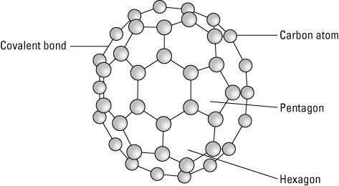

1. Make sure that each student has the chance to participate and try to build a part of the C60. Make sure that students read the instructions carefully and understand the geometric properties of the structure.
2. Once the C60 is constructed, explain to the students what the scale of what they have just build. A C60 has a diameter of 1nm. If students are having trouble realizing how small that is, explain that the C60 they built is less than a nm in diameter. In comparison, a soccer ball would be the size of the entire earth!

**Instructions to assist students if needed:**

1. Begin by assembling twelve pentagons. This will use all 60 of the atoms, but not all of the bonds

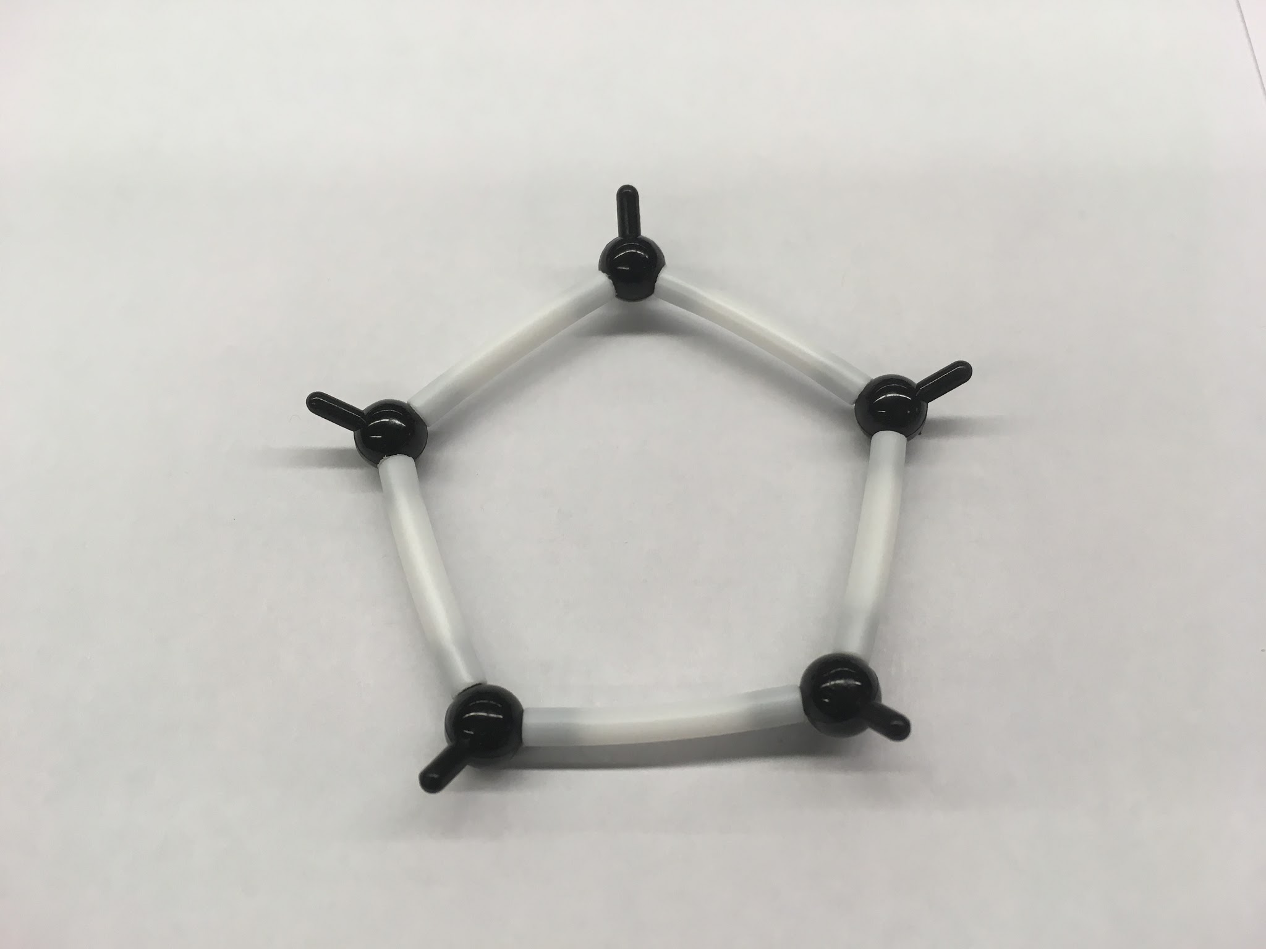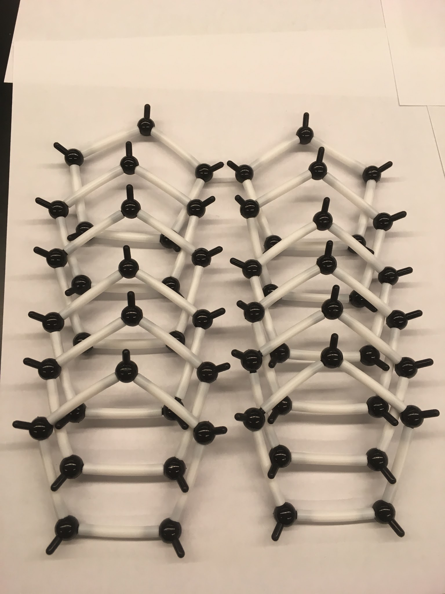

1 Pentagon 12 Pentagons

1. Connect five pentagons to a central pentagon like a snowflake as seen in the picture below. Make sure the tips are all pointed inward.

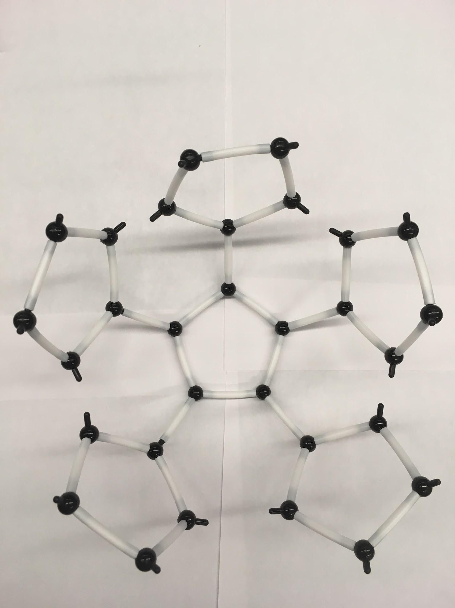

Snowflake Pattern

1. Connect the “arms” of your “snowflake” as shown below to form a “bowl.” Notice how this creates hexagons in the structure.

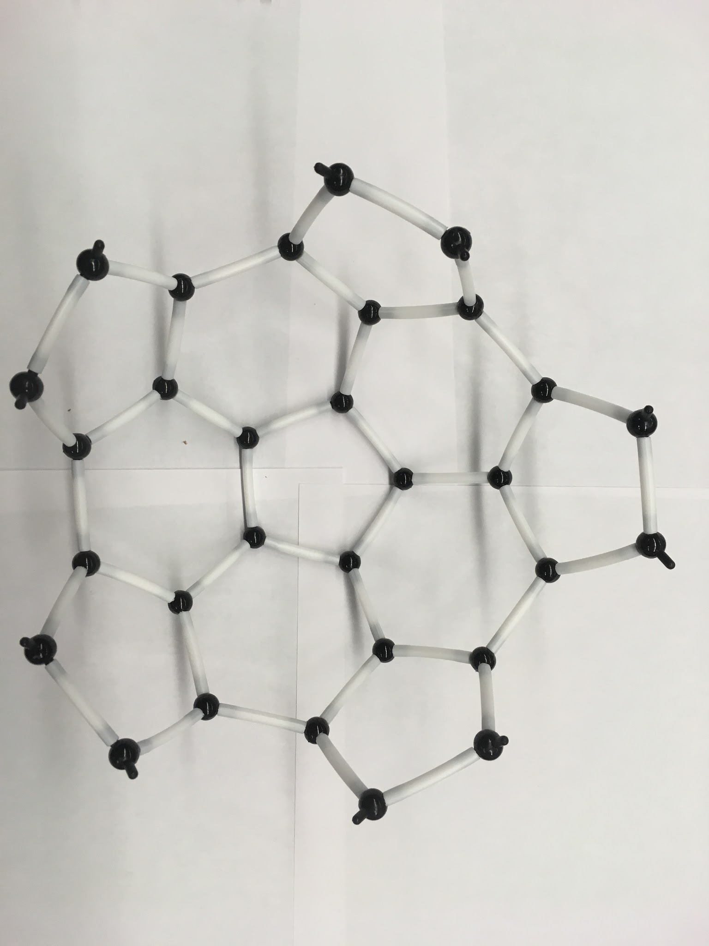

Bowl Structure

1. Repeat steps 2-3 with the other six pentagons
2. Align the two “bowl” So that it looks like they would mesh together like a jigsaw puzzle (see picture).

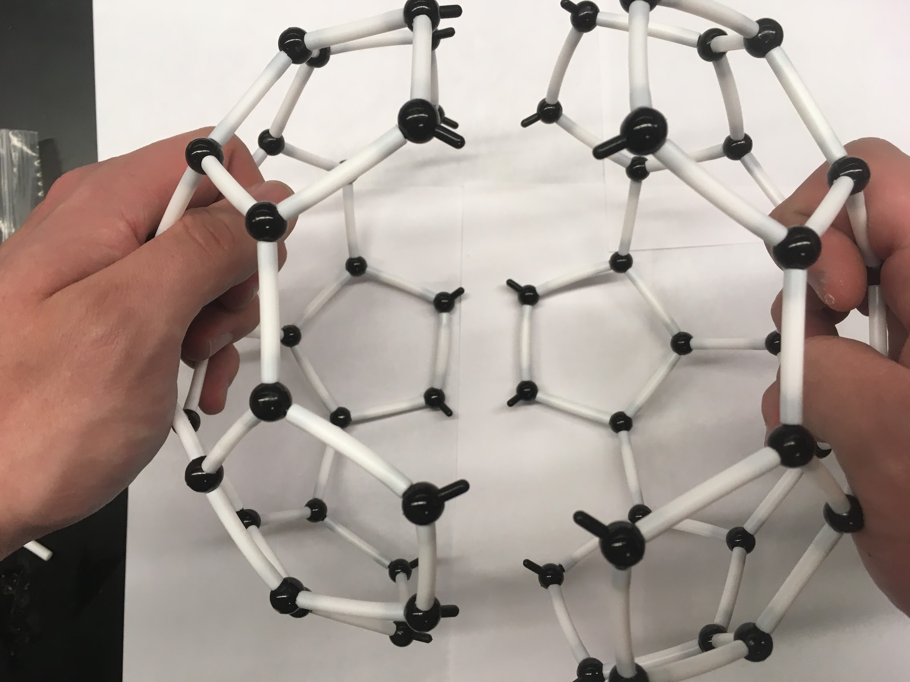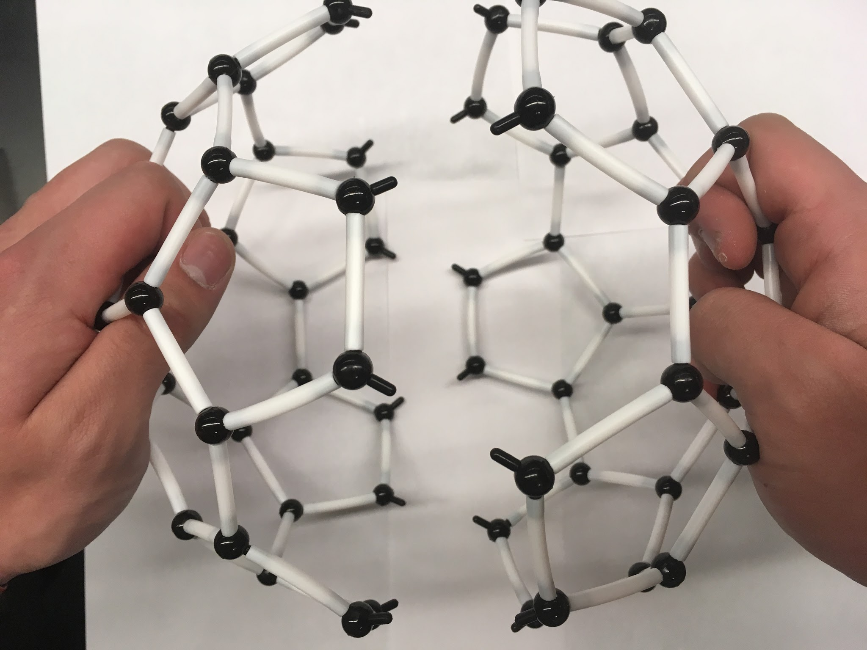

Incorrect Alignment Correct Alignment

1. Join the two bowls together by connecting the bonds that appear to point to each other. Note: This should create hexagons. **If you see a square, you made an error**; backtrack until you have two “bowls” again.

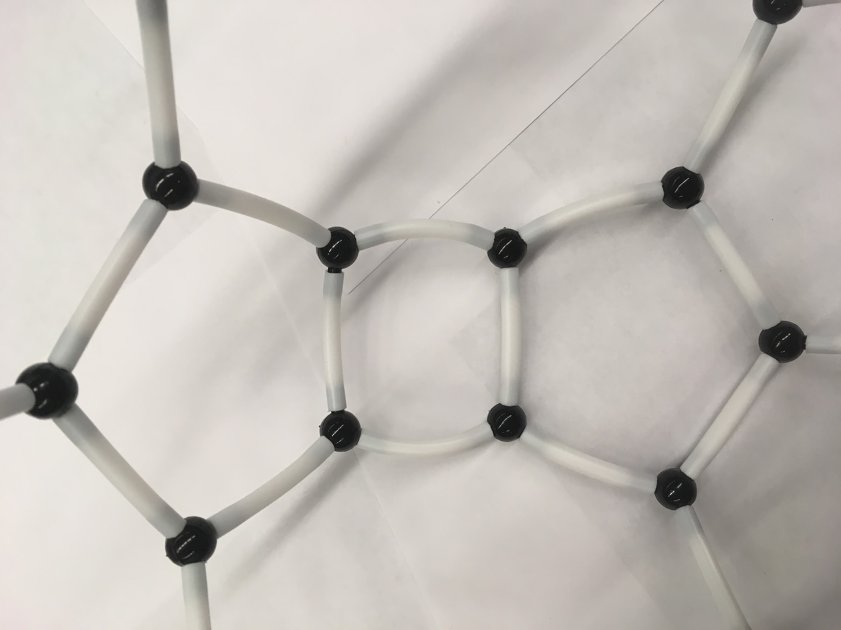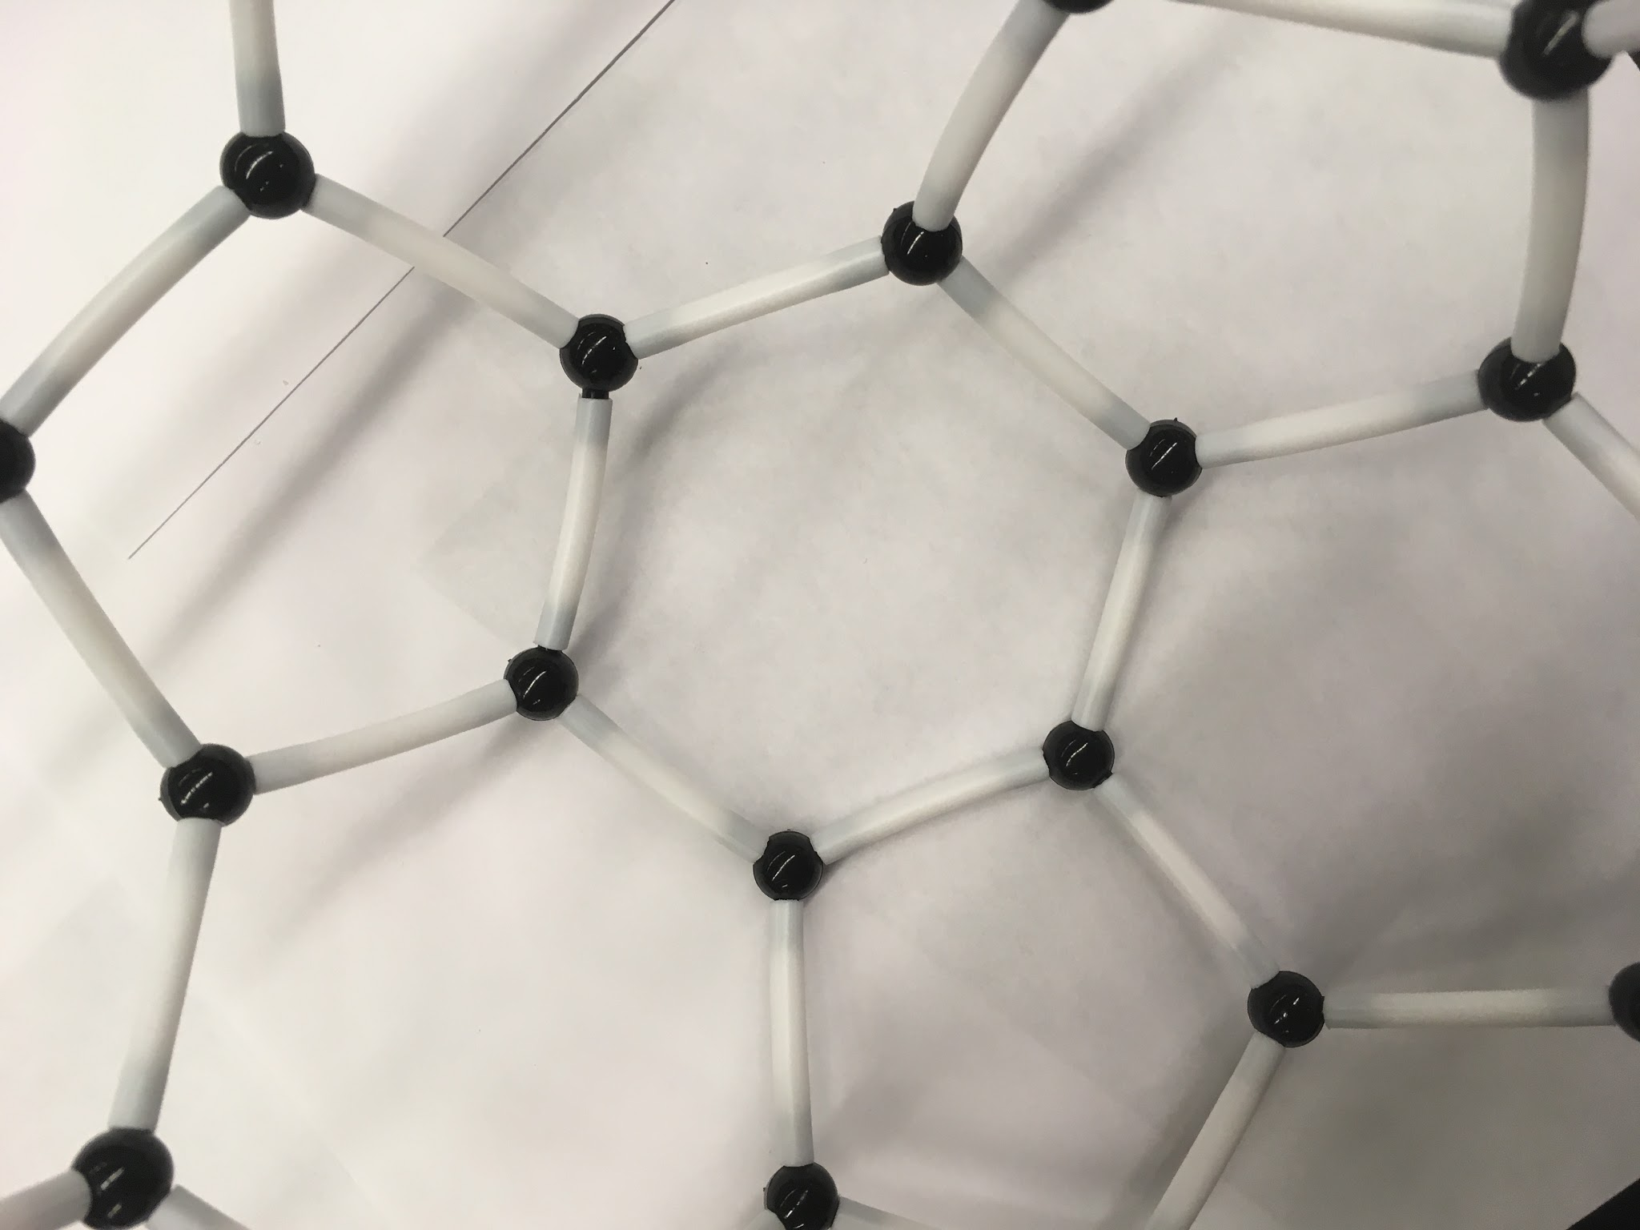

Incorrect Correct

1. Admire your completed buckminsterfullerene (C60) model it should look like the one below.

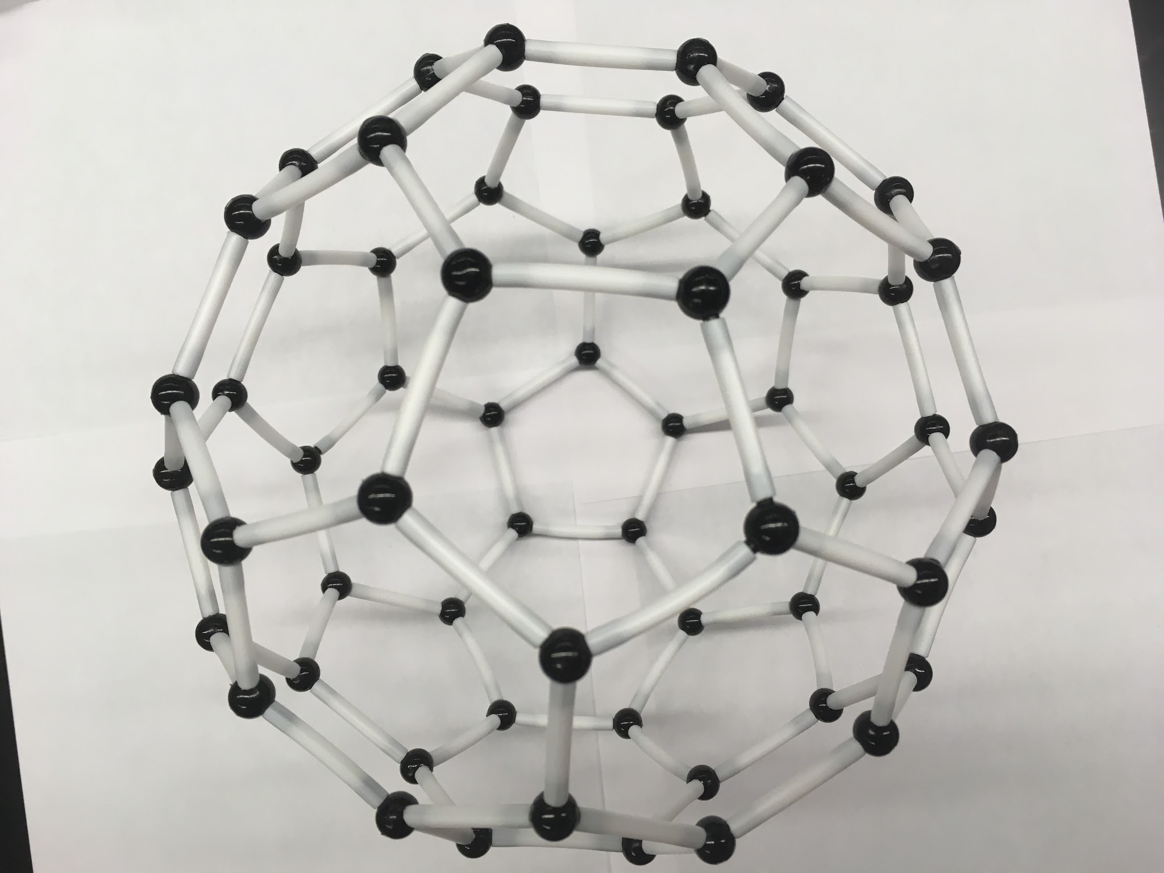

Completed buckminsterfullerene (C60)

**Activity Assessment:**

1. Have students fill out the student sheet.
2. Have students discuss some possible applications of the C60 buckyball.
3. Optional: Have a C60 building competition. Time yourself and compare your time with another team. Whichever team correctly builds a C60 ball the fastest wins (time it with a stopwatch).

<http://www.nano.gov/you/nanotechnology-benefits>

**Lesson 3: Nanotube**

**Essential Questions:** What is a nanotube constructed from? What specific properties does it add to objects at the nanoscale?

**Objectives:**

**Class Explanation:** Carbon makes up 20% of the human body. It is in our DNA, proteins, fossil fuels, and plays an important role in nanotechnology. It is the key component in the structure of buckyballs and nanotubes. **A carbon nanotube is constructed purely out of carbon atoms, and is so strong it has been considered the material necessary to build a space elevator!**

**Goal:** The purpose of this experiment is to enable students understand the properties of a nanotube. Additionally, students should be able to come up with real world uses for nanotube structures.

**Materials Required:** LSME Nanotechnology Kit’s carbon atoms and bonds and Station Instructions.

**Procedure:**

1. Students will be constructing a C60 bucky-ball in their assigned groups.
2. Begin by the structure of the Nanotube to students. Tell them that nanotubes are made out of interlocking hexagons that form a sheet. When you roll up that sheet into a cylinder, it makes a nanotube. Make sure they understand the pattern of nanotube they will be constructing (of the three types of nanotubes, we can construct a “zig-zag” from this kit).
3. Discuss: Ask the students if they are able to think of any uses of Carbon Nanotubes and proceed to tell them of their various uses. After getting several answers from the class, have students complete the assessment questions.
4. Students will then begin construction of their nanotubes.

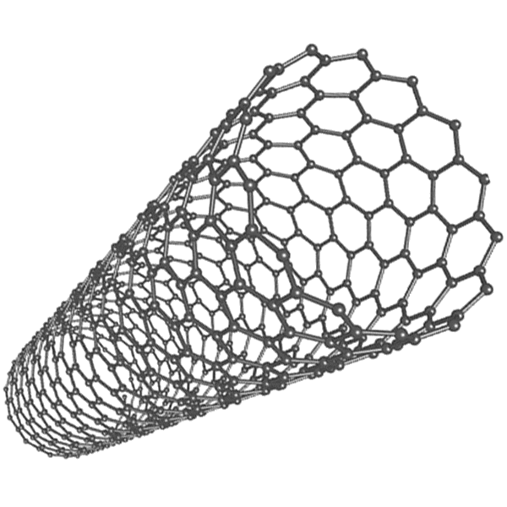

**Instructions to assist students if needed:**

1. Using a bond, connect two atoms. This simple piece you have just created makes up most of the actual nanotube.
2. Looking at the diagram below, see how the two-atom pieces interlock to create hexagons. Each row of hexagons is staggered, and by connecting the other extrusions with the white bonds, you can see how hexagons are formed.
3. Create four hexagons in a row. Once you have done this, you can curl the sheet of hexagons to make a “ring”. In order to do this, the hexagon must bend. Your hexagons will now be bent to make up two separate planes. This way we will have an 8 sided nanotube. Once one “ring” is complete, continue to build more rings on top of the original. Each kit can make a nanotube four rings high.

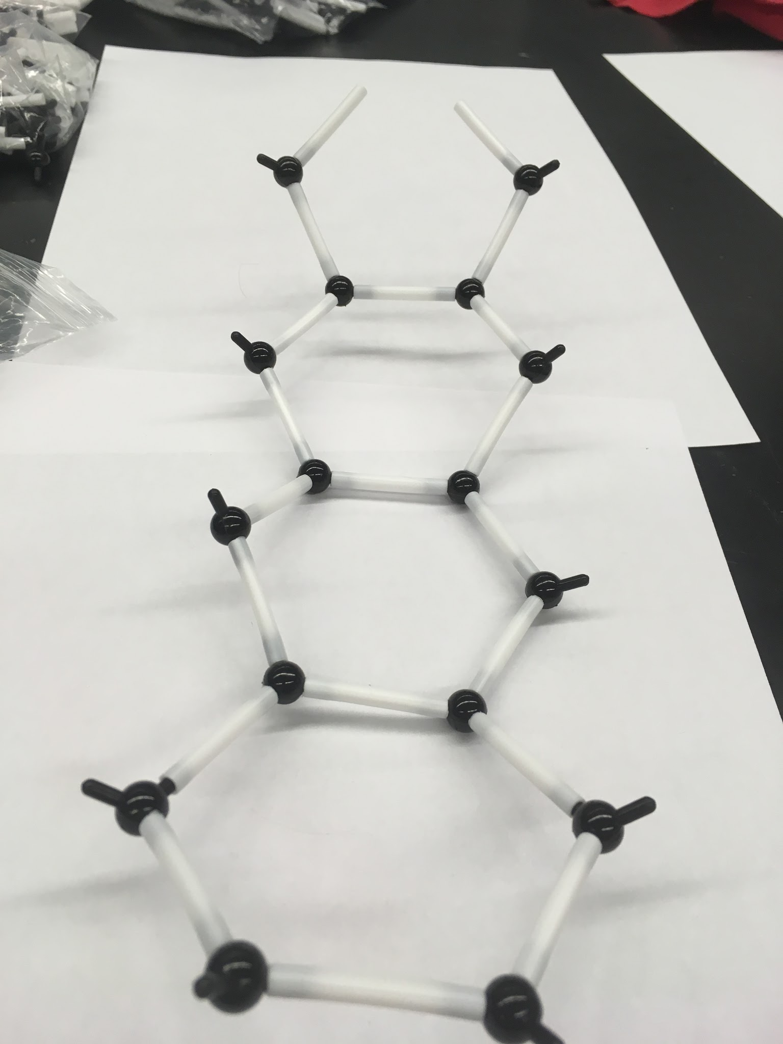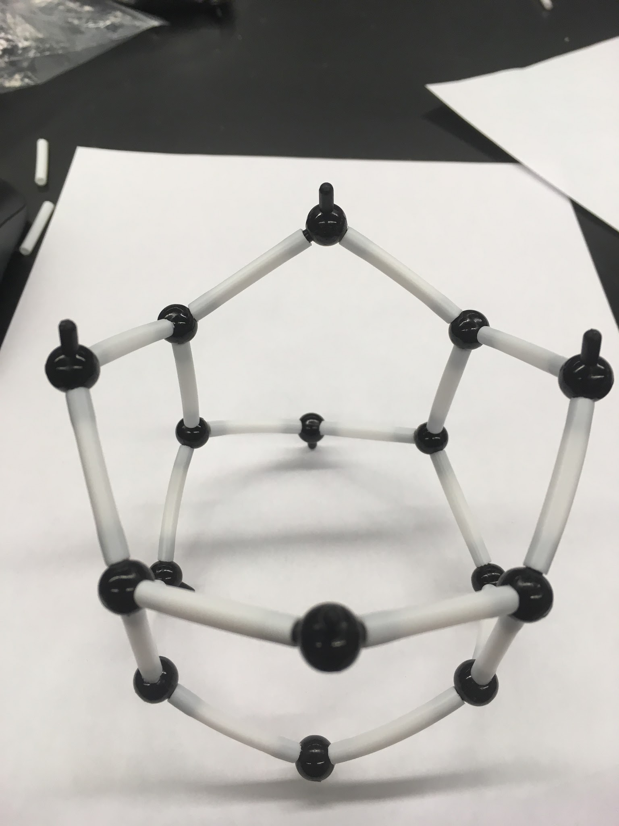

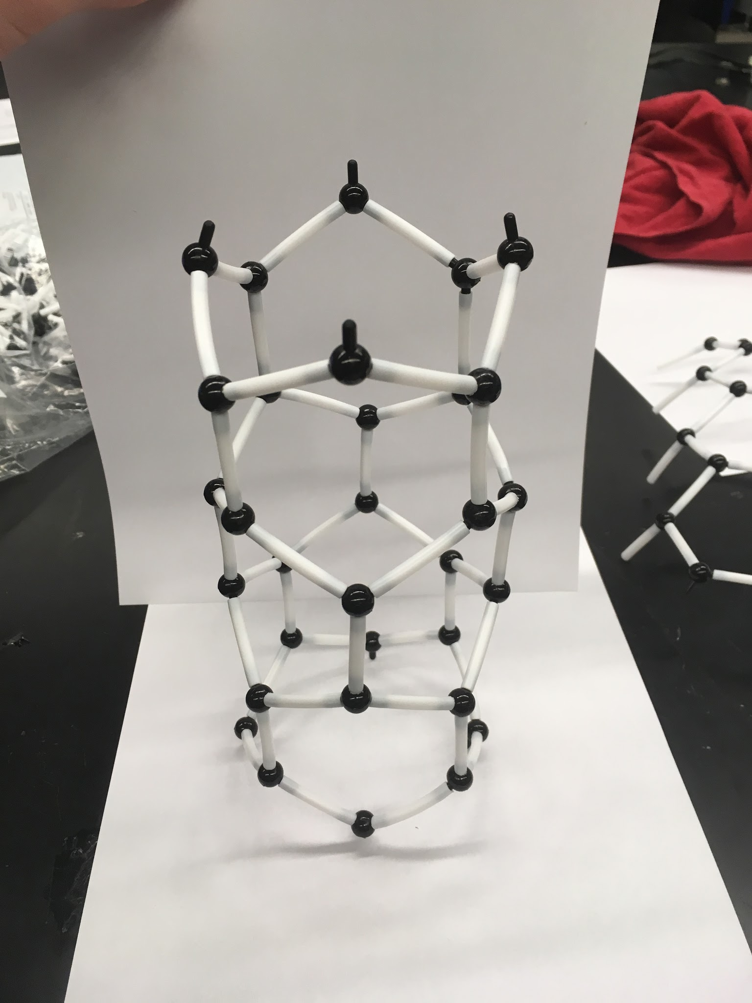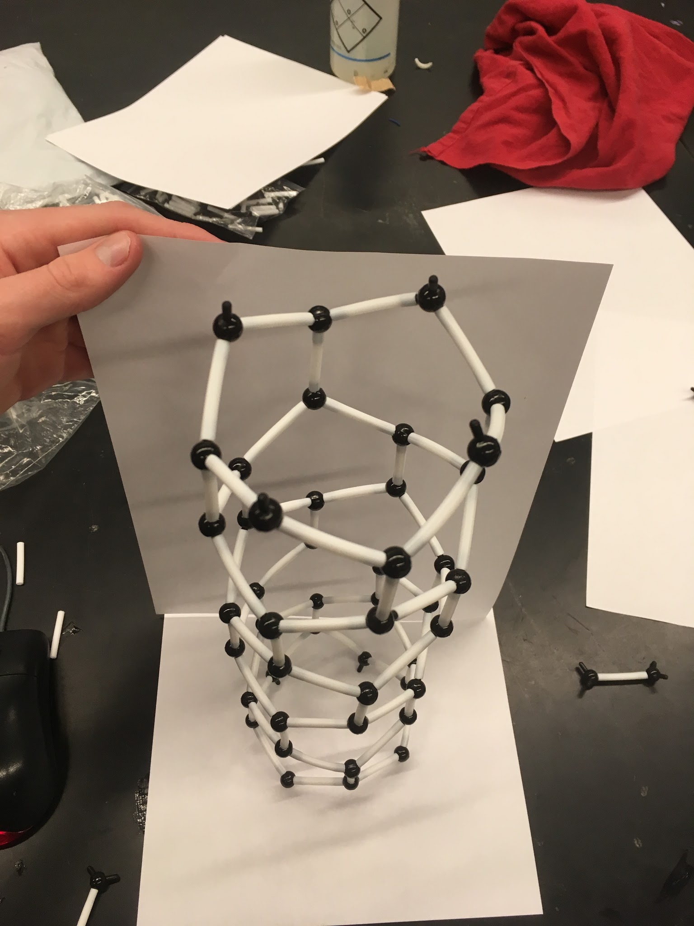

**Activity Assessment:**

1. Have students fill out the student sheet.
2. Discuss as a classroom some possible applications for nanotubes.

**Sources:**

* EPICS Design Process (2009) Purdue University.
* *National Nanotechnology Initiative*. N.p., n.d. Web.
* "Omni Nano Is a Nanotechnology Curriculum for High School Students." *Omni Nano*. N.p., n.d. Web. 11 Nov. 2015.
* "K-12 Educators | MRSEC Education | University of Wisconsin–Madison." *K-12 Educators | MRSEC Education | University of Wisconsin–Madison*. N.p., n.d. Web. 11 Nov. 2015.
* "What Is Nanotechnology?" *Nano.gov*. National Nanotechnology Initiative, n.d. Web. 21 Oct. 2016.
* Zhou, Quigxiang, Zhi Fang, Jing Li, and Mengyun Wang. "Applications of TiO2 Nanotube Arrays in Environmental and Energy Fields: A Review." *Science Direct*. Elsevier, 24 Sept. 2014. Web. 21 Oct. 2016.
* Nanomaterials in the Environment: Behavior, Fate, Bioavailability, and Effects Nanotechnology
* Chen, Zhuo; Westerhoff, Paul; Herckes, Pierre Environmental Toxicology and Chemistry; Sep 2008; 27, 9; Environmental Sciences and Pollution Management

<http://www.nanoscience.com/applications/education/overview/cnt-technology-overview/>

**Student Sheet Answer Key:**

**Station 1 - Nano-Fabric**

Explain what is happening on a molecular level when the water droplets gather on hydrophobic material.

*On a molecular level, water molecules are polar, and hydrophobic material’s molecules are nonpolar. These two species do not mix, and therefore, they repel each other. INCLUDE LOTUS EFFECT*

Draw an example of a hydrophobic molecule and an example of a hydrophilic molecule, and explain what makes each example molecule hydrophobic/philic.

*Students may have a variety of solutions for this portion.*

Brainstorm as a group applications for hydrophobic materials in their everyday lives. Write some down here.

*Students may have a variety of solutions for this portion.*

**Station 2 - Magic Sand**

Brainstorm ideas for hydrophobic building materials in industry.

*Students may have a variety of solutions for this portion.*

### Station 3 - Build a Nano-Soccer Ball

*Pre-Construction Assessment*

___108_____ internal angle of a pentagon

____120____ internal angle of a hexagon

____60____ carbon atoms (pieces)

Determine what type of bonds are holding the carbon atoms together. What is the definition of a covalent bond?

*A covalent bond is one where valence electrons are shared between atoms.*

How many valence electrons does a carbon atom have? How many bonds are formed? What is the molecular geometry of each atom in this structure?

*A carbon atom typically has 4 valence electrons. In this structure, three bonds are formed. This means that each atom has one free electron. The molecular geometry is Trigonal Pyramidal.*

What are some possible uses for C60 molecules?

*The free electrons allow for a flow of electricity, or electrons across the structure. This means that C60’s can be used to conduct electricity.*

### 

### 

### Station 4 - Build a Nanotube

The nanotube you built had:

____40____ carbon atoms (pieces)

____56____ atomic bonds (straws)

____16____ hexagons

What are some possible uses for nanotube molecules?

*Nanotubes are extremely strong structures, as well as strong conductors of electricity, given the free electrons. Students may mention the space elevator.*